Government Engineering College, Thrissur
CS333– Application Software Development Lab
Documentation -
Exp 8 – Built-in Functions
Exp 9 – Aggregate Functions

Date of Submission
30 September 2020

Submitted By
Kowsik Nandagopan D
Roll No 31
TCR18CS031
GECT CSE S5

Experiment 8

AIM
Implementation of Built in functions in RDBMS

Description
Implement built-in functions in MySQL to get valuable insight from the previously created database. Built-in functions include String functions, Date functions, Numeric functions, and some advanced functions. ( You can select 4 relevant functions from each category).

Output / Screenshots
String Functions
1. Select the consultants table and output string lenth of presentAddress and presentAddress
CHAR_LENGTH
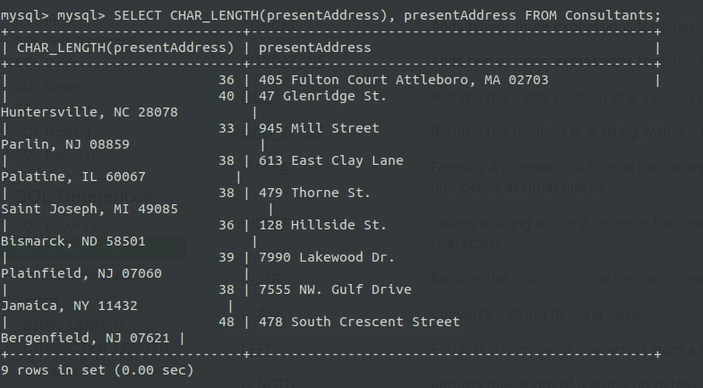

2. Select Consultants and print the name in the format:- Name (DESIGNATION)
CONCAT, SPACE, UPPER
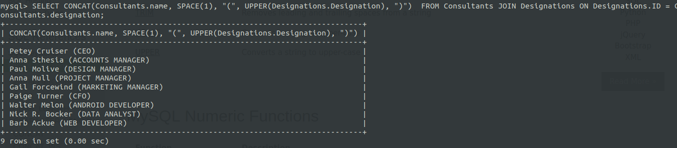
Date Functions
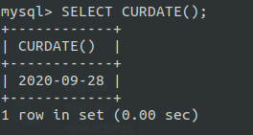
1. Display the current date in console
CURDATE

2. Select Project table and display the title, project start date. Date must be in format Day Date. Month must be displayed in name format
DATE_FORMAT
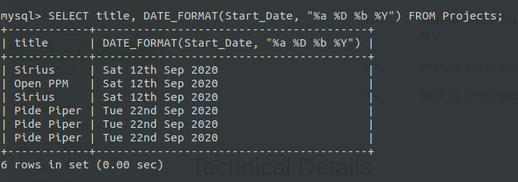

3. Display the number of days between start date and finish date for each project
DATEDIFF
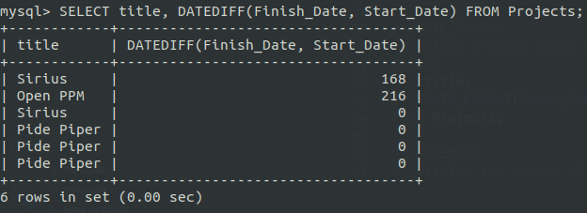
4. Display the date which is 10 days before finish date in specific format
DATE_SUB
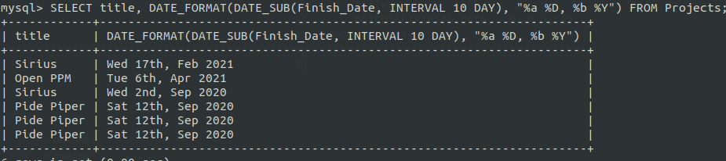
Numeric Functions
1. Print Value of PI
PI
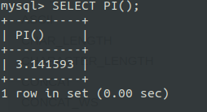

2. Select Project Transactions table and display the project name and entries of percentage completed of each resource. Percentage completed must be rounded of to one decimal
ROUND
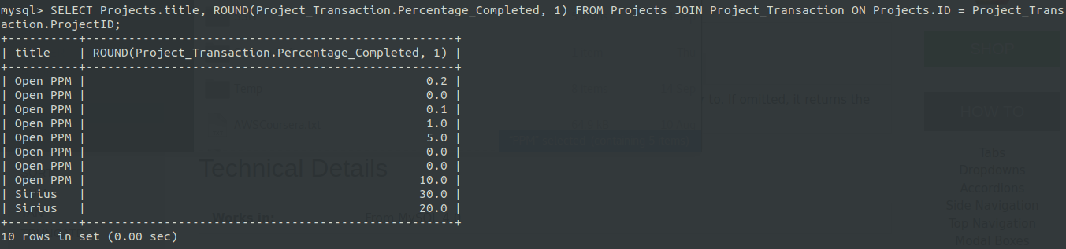
3. Select Project Transactions table and display the project name and entries of percentage completed of each resource. Percentage completed must be to nearest integer (not decimal)
FLOOR
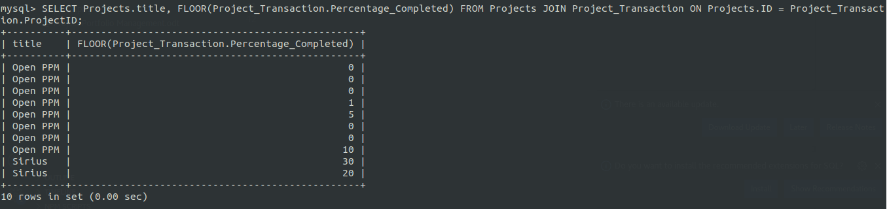
4. Display the minimum and maximum in project transaction
MIN, MAX
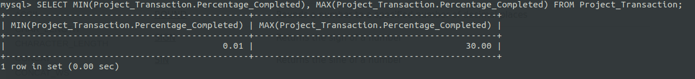

Advanced Functions
1. Display the status in text format corresponding to the integer format for each projects
CASE
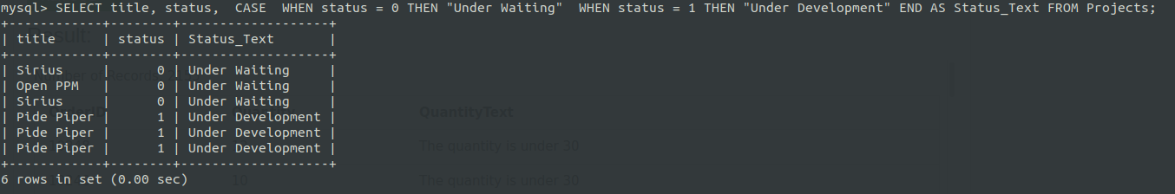
2. Display the user_status in text format. Use IF to convert to text
IF
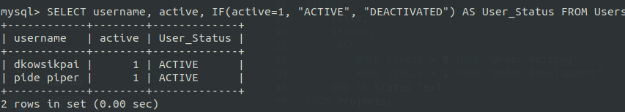
3. Display the details of the current connection
DATABASE, CURRENT_USER, CONNECTION_ID, VERSION
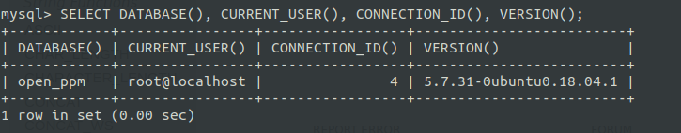

Experiment 9

AIM
Implementation of various aggregate functions in SQL

Description
Implement aggregate functions in MySQL to get valuable insight from the previously created database. Aggregate functions include Average, count, summation, maximum, minimum, standard deviation and variance

Output / Screenshots
1. AVG 2. COUNT
3. SUM
4. STD
5. VARIANCE
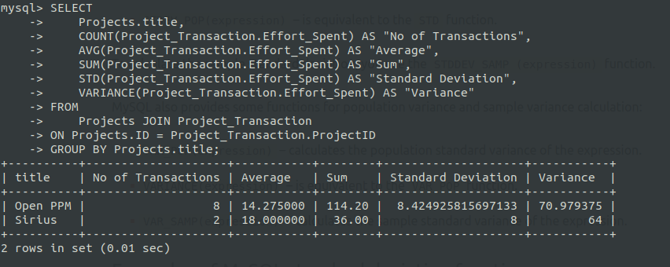
6. MIN, MAX

